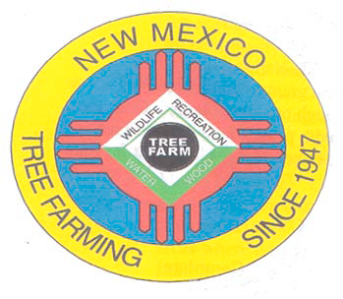
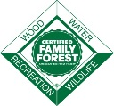
December 2021

DOUG BOYKIN
Chairman,
NM Tree Farm Committee

1118 Hope Farms Road Socorro, NM 87801
575-838-3027
Diboykin61@gmail.com
www.treefarmsystem.org/new-mexico

TREE FARM BULLETIN

NEVER SAY DIE
By Hart Allex, Outstanding Tree Farmer of the Year (2003 & 2015)

When Arnie Friedt (Cimarron District Forester) asked me to relate my forest restoration experiences, a couple months ago, I thought “this should be fairly easy.” After all it is a linear progression, right? Start at the beginning then follow, step by step, to the present. Yeah right. Life doesn’t work that way either.

If I had known, then what I know now. How many times do we repeat that phrase as we cruise through life? But if I had known, would I have started my first thinning project? Doubtful. My idea in 1987, was to make a few bucks. How hard can it be? Really?

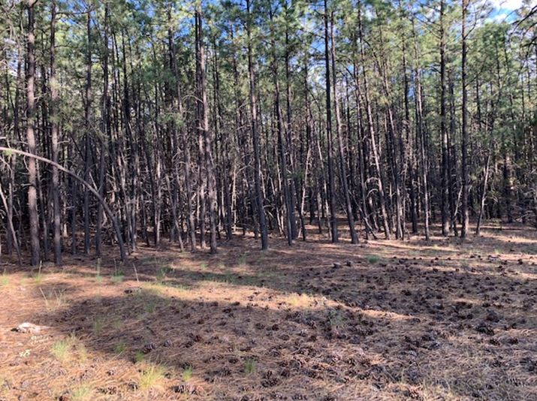
I was deep into construction on my house and shop and thought $500 bucks would get me further down the road on that objective. The cost share from USDA, Agricultural Stabilization and Conservation Service, at the time, was $588 an acre. I signed up to do ten acres. Both my sons were in high school, and between their wrestling meets promised to help. They were also going to peel latillas for the local sawmill. We had one chainsaw! Little did we know. It begins.

We actually finished that first project, many who sign up don’t, understandably. It is intensive labor, and we were not treating slash-just lop and scatter. Now I call what we did then a pre-thin. Doubt if we cut anything over five inches in that first pass. And you could no more walk through the mess we left behind than you could when they were standing as what I now call a jungle.
Condition of forest prior to treatment (1987)

Life intervened. The boys went on to college while Utilia and I returned to the Alaskan bush for another seven years of teaching to finish our retirement. It was to be 13 years before I again worked in my forest. The slash hadn’t moved or deteriorated. So, we started burning it. Little by little or “poco a poco” as they say around here.

Then, in 2003, I saw Chuck Leavell (spokesman for the American Tree Farm System & American musician) on a forest documentary. That got me to join the American Tree Farm System which opened my eyes wide. I was already making a second pass through the ten acres and slowly moving on through the rest of the 45 acres we had.

Arnie nominated us for Tree Farmers of the Year-2003. I didn’t think we had done enough to merit that award, but he did. Joining up with likeminded people and professional foresters simply served to push me harder down the road I was already on. Looking back at the photos from that time I realize how far I still had to go. A visit to Vermejo Park Ranch (owned by Ted Turner) near Raton, NM cemented my direction. They were thinning approximately 1,000 acres annually!

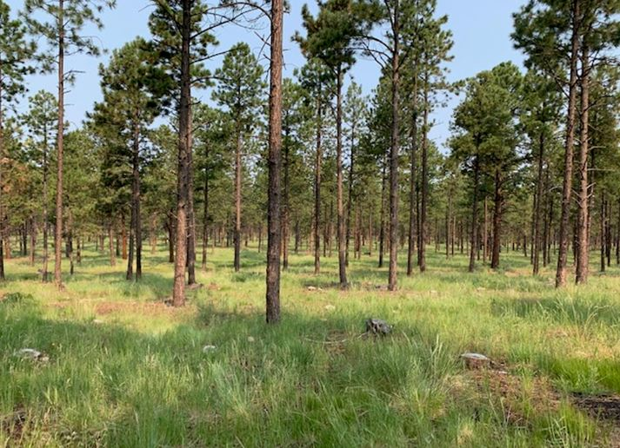
Eventually we thinned the entire 45 original acres three times. At the beginning, I chopped the trees down and gave away the wood. Others branched and bucked before taking the wood home. Utilia and I spent many days/weeks burning slash each year in late Fall.

But something was happening. Vegetation was coming back into the forest. It was almost imperceptible but, year by year, it was obvious. Reforestation actually works! Who would guess that 85% of the tree stems needed to go away first? Scary, inconceivable but true. After about five years I could see the difference in the ponderosa pines. Their branches and needles were filling out.
“Vegetation was coming back into the forest.”

We attended many Tree Farmer functions, all over the state, and had a chance to learn from others while seeing their efforts. It was a great family we had joined!

I tried to get many of my neighbors to sign up. My 450-foot-wide property would not survive a crown fire coming through their jungles. I was not very effective, though we did have a handful. Most could not do the work or afford to have others do it for them. I told my Honey if I ever ran into a windfall, I would buy property to restore it myself. God was listening. And that is what happened next.

We started buying neighboring properties in 2012. We have 17 (almost 360 acres) now. My crew and I started thinning the most recent purchase (27 acres) this summer. So, I have almost ten years in this new forest restoration project. About a third of the acres were in cost share programs with Taos Service Center, Natural Resources Conservation Service (NRCS) and Taos, Soil and Water Conservation District (SWCD).

Rewards came and then some. Frustrations? For sure. Challenges-always. Labor, time, and money throw monkey wrenches in any plan, but a forest is a living breathing entity. Add in weather, government bureaucracy, paperwork, labor, and the problems mount up quickly. But? Never say die, is my motto. I realized this is what I am her for. Now it is my passion. My previous life efforts seem puny by comparison.
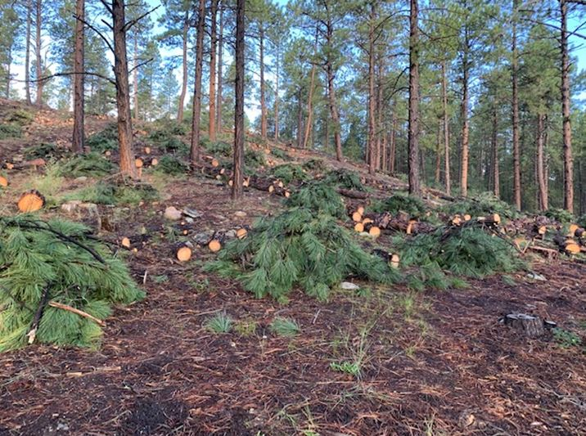
One constant, throughout the process, has been my customers. We keep the price of firewood low enough, so they come from as far away as 70 miles to take a load. Over the years we have watched many thousands of pickups, trailers, flatbeds and even a few vans and SUVs haul out the good stuff-670 loads in 2020! Selling our product is a job all by itself but leaving the wood behind just causes more problems.

Slash burning is another constant with its own set of problems. We have burned probably tens of thousands of piles. At the beginning, they were too big, and we scorched the earth and raked to mineral soil around them. Bad idea-invasives. As I sprayed the invasives, each summer, I came up with the solution. Make smaller piles, burn when the ground is wet or cold and leave the duff alone. Worked! Such a simple solution. Of course, people and government are all over this issue. Making peace with Forest Service, county, state, and local fire chief requires dancing the dance. My objective is forest restoration, all the rest is white noise. Stay focused Allex!
“We keep the price of firewood low enough, so they come from as far away as 70 miles to take a load.”
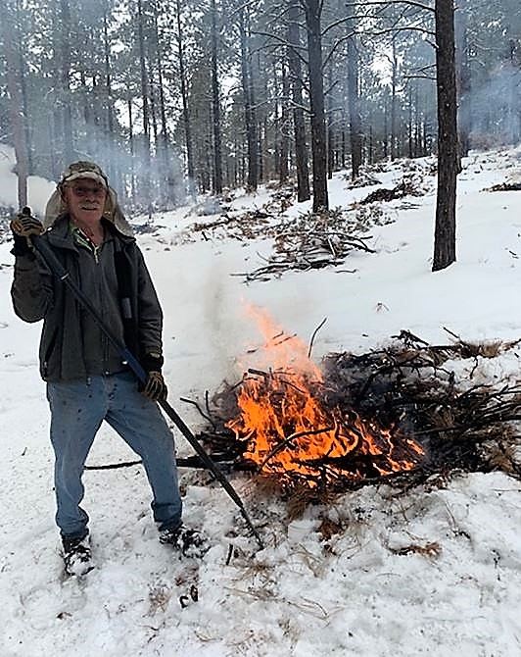
Labor is also a hit and miss affair. Over the years I have hired over 150 guys and gals from our community and nearby. Most couldn’t cut the strenuous labor-no endurance, even though we reduced the work shift from eight hours to five over time. Many didn’t have the work ethic needed either. I found gals to be better at piling. Not macho enough task for the sawyers. But all sawyers needed the training, so they would know how to leave the slash when they were on a saw. Over the years I reduced my crew size from mid-teens to half a dozen. I wanted to cut trees not monitor the workers! We could actually thin about an acre a day and see the results of our efforts right away.

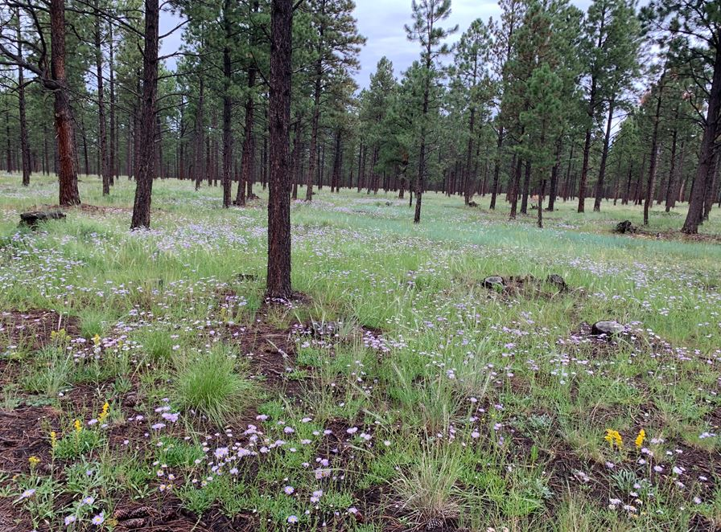
Again, in 2015, our work was nominated for the New Mexico Outstanding Tree Farmer of the Year Award. This time I knew we deserved the attaboy. We were knocking down trees, selling wood and burning slash at a furious clip, year after year. My crew participated in the luncheon and were witnessed working the forest by the visitors.
“Slash burning is another constant with its own set of problems. We have burned probably tens of thousands of piles.”
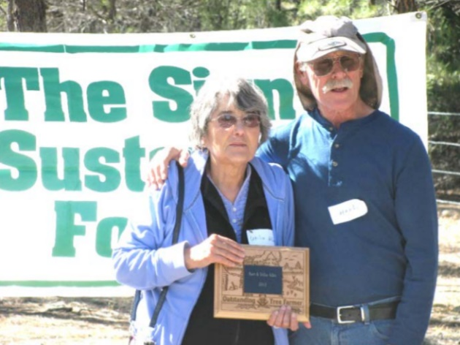
Utilia & Hart Allex (2015)

“Again in 2015, our work was nominated for the New Mexico Outstanding Tree Farmer of the Year Award. This time I knew we deserved the attaboy.”

I regularly tell my crew to look at the satellite photos. Their work can be seen from space! Not many of their peers can claim that. As if the resulting forest was not enough testament for their efforts! Watching my crew give “the spiel” of what we are doing and why, to others, warms my heart. Education is not just for the customers.
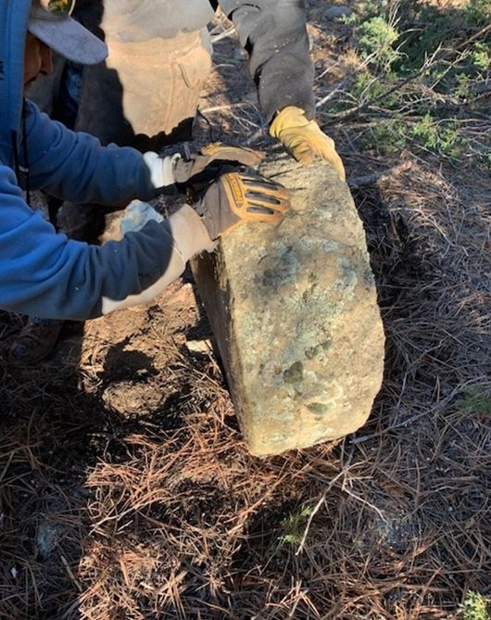
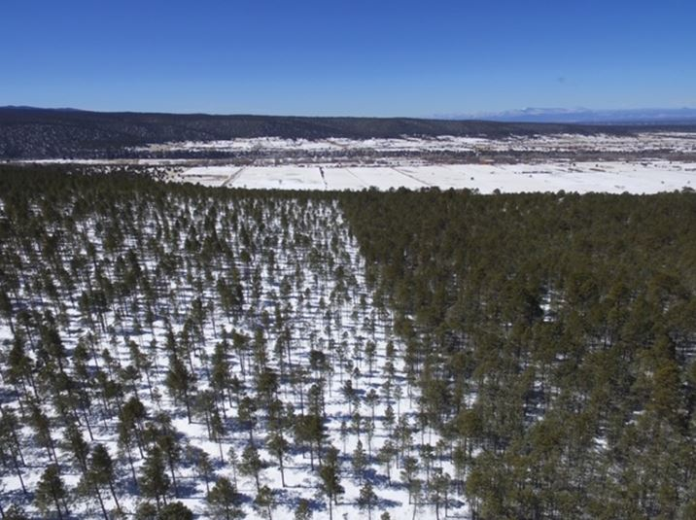
Now and again, we have an incredible anecdote to go with our efforts. Most recently, I stumbled across a mill stone while cutting the juniper it was sitting next to. The stone was perfectly formed and, for some reason, left in the forest after the massive logging done in the 1920s before the land, uphill, was sold to the Forest Service by the railroad company that owned it after the land grant it was part of was “taken” from locals. The private forest was also cut by the logging company (Sant Barbara Rail & Tie Co.) at the same time.
“Watching my crew give “the spiel” of what we are doing and why, to others, warms my heart.”

So maybe, just maybe knowing what I know now I would have started thinning, as I did in 1987. But I would have done it much more efficiently.

COMMITTEE MEETING

All Tree Farmers are invited and encouraged to take part in our 3rd New Mexico Tree Farm Committee Meeting of the year (three held annually). Please join us at 1:00 on Thursday, December 16th, 2021, at the New Mexico Department of Game and Fish office located at 7816 Alamo Rd NW, Albuquerque, NM 87120. Come out and hear what other tree farmers have been up to and share your tree farm accomplishments with the group. We look forward to visiting with you. If you have any questions, please contact Arnie Friedt at arnie.friedt@state.nm.us
“The stone was perfectly formed, and for some reason, left in the forest…”



Your New Mexico Tree Farm Committee would like to take this opportunity to wish you and yours Happy Holidays and a Happy New Year!

