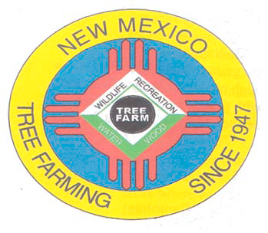
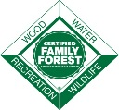
November 2021

DOUG BOYKIN
Chairman,
NM Tree Farm Committee

1118 Hope Farms Road Socorro, NM 87801
575-838-3027
Diboykin61@gmail.com
www.treefarmsystem.org/new-mexico

TREE FARM BULLETIN

FOREST LEGACY PROGRAM
By Carol Bada, Forest Legacy Program Manager, NM Forestry Division

The U.S. Congress created the Forest Legacy Program in 1990 to help landowners, state and local governments, and land trusts identify and protect environmentally important private forest lands that are threatened by present or future conversion to non-forest uses. Since its creation the Forest Legacy Program has conserved over 2.8 million acres of forest land and expanded across the country to 53 states and territories.

The program is funded by the Land and Water Conservation Fund, which invests a small percentage of federal offshore drilling fees toward the conservation of important land, water, and recreation areas for all Americans. The passage of the Great American Outdoors Act provides permanent funding for the Land and Water Conservation Fund. For current information on implementation of the Great American Outdoors Act please visit our website.

The Forest Legacy Program is authorized through the federal Farm Bill and made available to the State of New Mexico by a grant from the USDA Forest Service (USFS). Landowners who choose to sell conservation easements to the state may sell the development rights to all or part of their properties. They are encouraged to form partnerships with land trust organizations that can help them with their property appraisals, and tax or estate planning. Up to 75% of the easement value is provided through a federal grant. The other 25% must be funded by non-federal sources or donated by the landowner.

Conservation easements are held in perpetuity by the state and effectively retire the rights to subdivide and develop the properties for non-forest uses. Participating landowners retain all other rights to their properties including occupancy, use for enjoyment or profit, and transfer to heirs or sale to new owners. Property taxes are paid on the retained rights, as determined by the County Assessor. These private forests continue to produce wood products, provide wildlife habitats and open space, contribute to watershed integrity, help combat climate change through carbon sequestration, and are protected from urban sprawl.
New Mexico currently has three Forest Legacy conservation easements. The Horse Springs conservation easement consists of 5,000 acres in Catron County. The High-Country Ranch conservation easement is 11,655 acres in Rio Arriba County. The Vallecitos Mountain Refuge conservation easement consists of 132 acres and is also located in Rio Arriba country.
There is another Forest Legacy Program project currently in progress in Rio Arriba County. This is the Brazos Cliffs project near Chama, NM; 6,780 acres of the Brazos River watershed.

Forest Legacy Program Eligibility Criteria
To be eligible for inclusion, a property must be 75% forested with timber or riparian woodland species and meet the following four eligibility criteria. Properties less than 40 acres in size will generally not be considered unless they contain significant features, such as endangered species habitat or rare types of forest.

1. Threat
To meet this criterion, the property must be threatened by at least one of the following:
Conversion to non-forest uses;
Further subdivision into smaller parcels.

2. Public Values
To meet this criterion, the property must possess one or more of the following public values:
Natural aesthetic or scenic values;
Public education opportunities;
Public recreation opportunities;
Riparian areas;
Fish and wildlife habitat;
Threatened or endangered species habitat;
Cultural and historical resources;
Traditional forest uses; and/or
Other important ecological values.

3. Planning
To meet this criterion, the property must have one of the following:
A Forest Stewardship Plan or equivalent forest management plan approved by the State Forester or his or her designated representative in accordance with National Forest Stewardship Program criteria, or where land is acquired in fee or timber management rights are transferred in the conservation easement, a management plan will be developed by the organization acquiring those rights.

4. Funding
To meet this criterion, there must be non-federal matching funds of at least 25% of the Conservation Easement value available in the form of cash and/or in-kind contributions.
Private forest owners and local government managers who wish to apply to the NM Forest Legacy Program can contact Carol Bada at carol.bada@state.nm.us
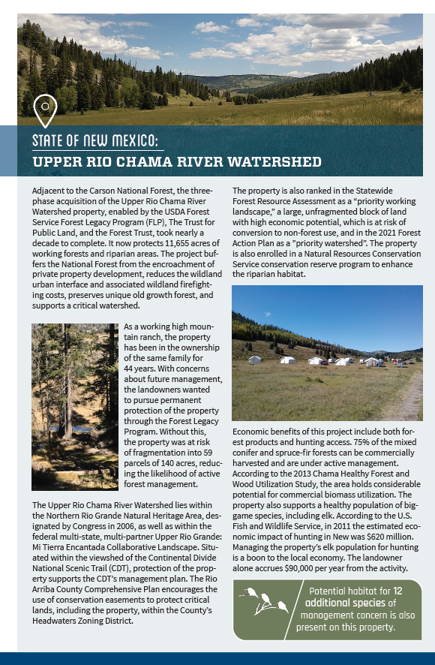
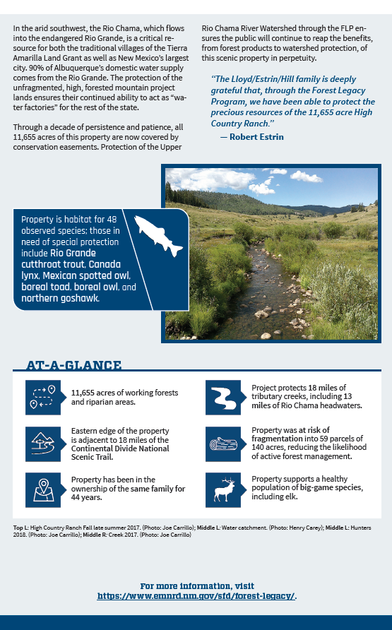
"The above content was produced by the Western Forestry Leadership Coalition, in cooperation with western state forestry agencies and the USDA Forest Service."

COMMITTEE MEETING

All Tree Farmers are invited and encouraged to take part in our 3rd New Mexico Tree Farm Committee Meeting of the year (three held annually). Please join us on Wednesday, December 8th, 2021. Join us and hear what other tree farmers have been up to and share your tree farm accomplishments with the group. We look forward to visiting with you. If you have any questions, please contact Arnie Friedt at arnie.friedt@state.nm.us

