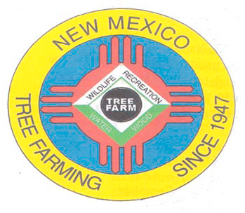
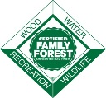
March 2022

DOUG BOYKIN
Chairman,
NM Tree Farm Committee

1118 Hope Farms Road Socorro, NM 87801
575-838-3027
Diboykin61@gmail.com
www.treefarmsystem.org/new-mexico

TREE FARM BULLETIN

TREE FARMS MATTER!
By David Old, Tree Farmer and Owner of Old Wood LLC

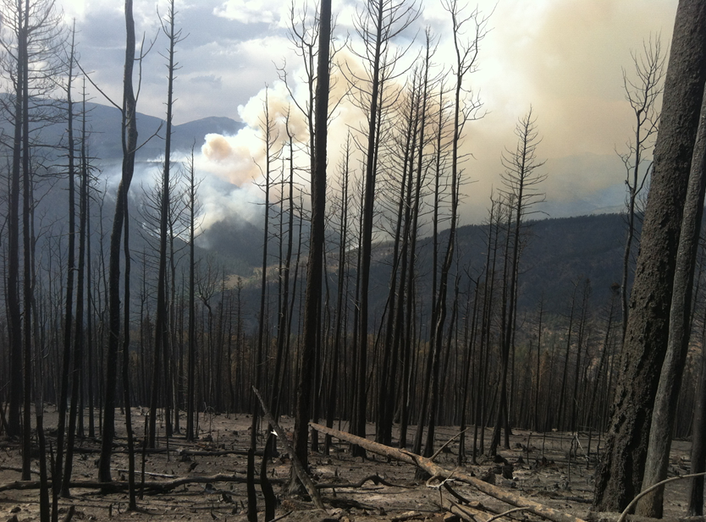
Old Wood LLC was founded on the Viveash Ranch back in the late 70’s but became a full-time sawmill/wood products business in 1998. Our history and backstory can be found on our website at www.oldwood.us. Very long story shorter, after the Viveash Fire of 2000 burned over 1,400 acres of our timbered land, we moved to Las Vegas where we ‘went after’ the flooring and architectural wood products business. We’ve exported to many countries from Kuwait to Kuala Lumpur, Saudi, China, Japan, and Jamaica. It’s been a fun but long and difficult financial journey, but we’ve had a great deal of support from our partners in forestry, agency, non-governmental organizations, communities around the region and Collaborative Forest Restoration Program (CFRP), Value Added Producers Grant and the Wood Innovation program of the United States Forest Service. The ranch burned again in 2013 and we spend our spare time ‘tree farming’ with a D6 mostly, clearing large areas of burnt mess. Our Tree Farm ‘shingle’ is still out although it’s mostly rehab work, we do these days. Planting will come but we have large areas to burn first and that’s a big challenge for a small family on a budget.

We’ve managed to survive: Always in the background is the desire to practice and encourage sound, scientific forestry of benefit to our lands, environment, and communities. We believe that a healthy forest is always better off with a healthy forest industry undergirding it. We’ve made floors, firewood, walls, shavings, moldings, tables, shelves, bar tops and counters, cutting boards and anything else we can manage to sell. If you can’t sell it, there is virtually no point in making it unless you are coming from a purely hobby shop perspective. The same can be said about Tree Farming. As a form of healthy large-scale gardening or self-gratification it beats golf any day, but the serious aspects of forest ownership are usually unavoidable if you’re the one engaged in the work. One thing forestry always produces is excess ‘fiber’, aka branches, needles, and ‘rubble’. Mulch is good, chips not so hot as they tend overwhelm the area with a very industrial look so hauling the material off the property is almost always desirable. Firewood, give it away if you have to. Let people know you have it and it will often go away but sometimes you have to work at giving it away.

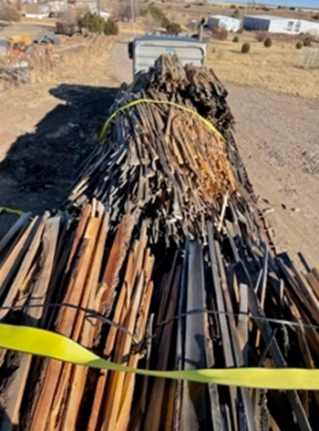
Old Wood has found a wonderful way to ‘get rid of’ large volumes of leftover sawmill and flooring production edging occupying way too much space at our mill: The Navajo Nation has, in the past two years, lost a huge source of primary home heating as ‘current policy’ has successfully shut down several coal mines and power plants around the Navajo Nation. Covid has hurt of course and the sort of general dysfunction we are all getting too familiar with, has led to many elderly and needy members of the Navajo Nation being seriously in need of heat. They need decent wood stoves, and they need wood to burn. How could we all help? Consider loading up a truck and delivering it to one of the many Chapter houses around the state of NM from Cuba to Gallup and beyond. Talk to friends and church members; get them to help you generate some useable wood that is a heat lifeline to needy folks out in the arid lands of the Navajo Nation. You will be able to thin, remove understory/ladder fuels, get some exercise, create good will for your own place and the Tree Farm Network as you ‘gently educate’ folks about your intentions and you underlying efforts at forest management. Your efforts might well culminate in a road trip with your truck or trailer to some remote and often amazing place out on the reservation you’d otherwise never see or enjoy. Stop along the way at legit trading posts; you’ll be amazed at the entire cultural ‘thing’, and possibly find remarkable deals on jewelry, blankets and the usual ‘tourist stuff’ but you’ll be out in the real world where prices are also real, and your purchase benefits the locals directly rather than some jewelry buyer from Gallup! These trips are fun and interesting; guaranteed.
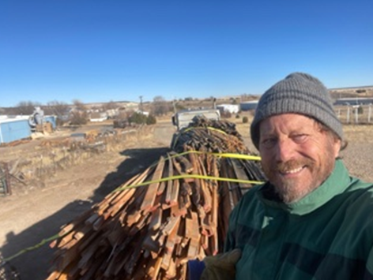
Reach out to your regional New Mexico Energy Minerals and Natural Resources Department (EMNRD), Forestry Division folks for more guidance on how you might get involved and consider creating a network of friends who might enjoy being part of a noble effort. There is a strong need for decent modern woodstoves as well if you come across any. Old Wood recently used our CFRP supported semi-truck to haul a load of our excess material to Torreon Chapter, supported by USFS, ENMRD and the local Chapter House.

We’d be happy to connect you as possible, www.oldwood.us www.firewoodnm.com
David Old, (505)454-6007 david@oldwood.us

The New Mexico Tree Farm Committee will be celebrating Cottonwood Gulch successes at their Tree Farm on April 23rd, 2022, from 10:00 AM through 2:00 PM. Everyone receiving this bulletin is cordially invited to come up and tour the Cottonwood Gulch Tree Farm and enjoy a day in the forests. Lunch will be provided. Please let us know if you will be attending to make sure we have enough food prepared for lunch. RSVP by April 20th, 2022, by contacting Todd Haines at todd_haines@hotmail.com or text/call 505-943-1033. Please consider attending, you won’t be disappointed. It will be an interesting and educational day.

If you plan on attending, please RSVP by April 20th, 2022
Contact Todd Haines
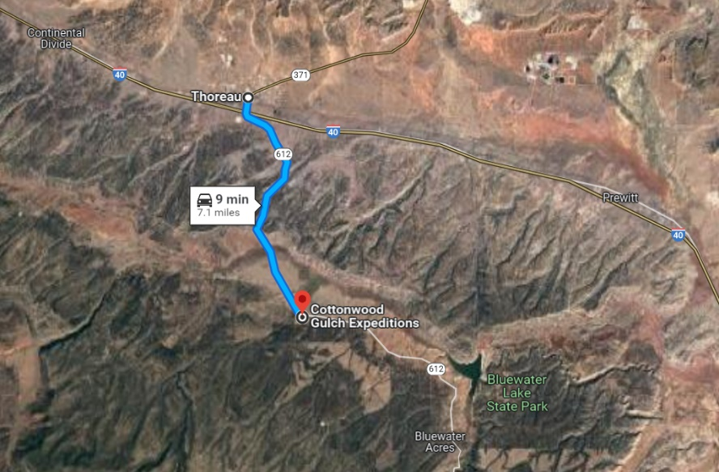
todd_haines@hotmail.com
or text/call 505-934-1033

Directions to Cottonwood Gulch:
Cottonwood Gulch is located west of Bluewater Lake between Grants and Gallup NM. On Interstate 40 go to the Thoreau Exit and proceed south and follow state road 612 for 7.1 miles. The Base Camp entrance is south (right side) of the highway. Proceed about ¼ mile to the Headquarters.

1) NMTFC 2022 RAFFLE
NEW MEXICO TREE FARM COMMITTEE 2022 RAFFLE
FIRST PRIZE: Unit 45 Private Ranch Cow Elk Hunt Landowner Tag
Donated by the Gascon Ranch Tree Farm
SECOND PRIZE: Stihl Chainsaw
Donated by Forest Fitness
THIRD PRIZE: Custom Made Metal Art
Donated by Carl & Lisa Bartley
Winner of the tag will be responsible for NM Dept of Game and Fish License
Winner will need to contact the ranch to schedule hunt dates
Winners to be drawn at the August 2022 NMTFC Meeting
$10.00 Each
To purchase your 2022 Raffle ticket(s) send a letter and check (payable to NMTFC) to:
Doug Boykin
1118 Hope Farms Road
Socorro, NM 87801
Doug will in turn send you your numbered 2022 Raffle ticket stub(s)

2) COMMITTEE MEETINGS

All Tree Farmers are invited and encouraged to take part in our 2nd New Mexico Tree Farm Committee Meeting of the year (three held annually). Please join us in August 2022 and hear what other tree farmers have been up to and share your tree farm accomplishments with the group. We look forward to visiting with you. If you have any questions, please contact Arnie Friedt at arnie.friedt@state.nm.us

3) EQUIPMENT FOR SALE

Brand new aerator for a Multi-Flo Wastewater Treatment System. Great to have as a backup if you don’t need it now. Priced at $350.00 which is about half price. Contact Duane Trythall at DTrythall1@outlook.com or 505-821-1319.

4) E-MAIL INSTEAD OF SNAIL MAIL

Would you prefer to receive your Tree Farm Bulletin by e-mail instead of snail mail? Is so, contact Arnie Friedt at arnie.friedt@state.nm.us and provide him with your contact information. By receiving your Tree Farm Bulletin by e-mail our operating costs are reduced. Thank you for considering this option.

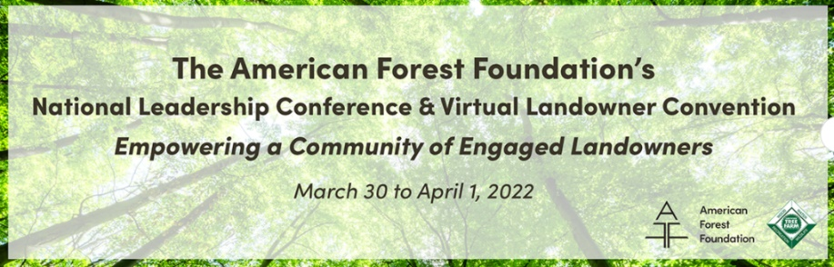
5) SAVE THE DATE

American Forest Foundation’s 2022 National Leadership Conference & Virtual Landowner Convention March 30 & April 1, 2022, Register at https://events.hubilo.com/aff-2022-national-leadership-conference/register

