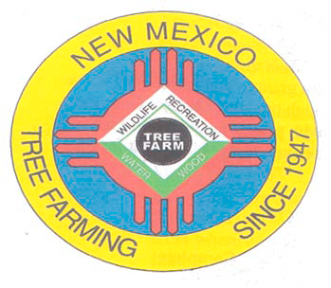
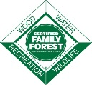
September 2021

DOUG BOYKIN
Chairman,
NM Tree Farm Committee

1118 Hope Farms Road Socorro, NM 87801
575-838-3027
Diboykin61@gmail.com
www.treefarmsystem.org/new-mexico

TREE FARM BULLETIN

THE HISTORY & INVOLVEMENT OF THIS
ACTIVE WORKING CERTIFIED TREE FARM
by John Bartley, Gascon Ranch Tree Farm #033-81

The family history of this ranch, known as the Gascon Ranch, dates back into the 1850's. My great grandfather bought the ranch from my wife Tamera's great-great grandfather, Richard Dunn, about 1920. Her great-great grandfather came here in 1869; he married Marie Pendaries, the daughter of Jean Pendaries in 1872; in 1880 he put together a steam powered sawmill right here at headquarters, logged the timber and built a 2-story frame house (where our newer house currently sits; sadly, the old house had to be torn down in 2003).

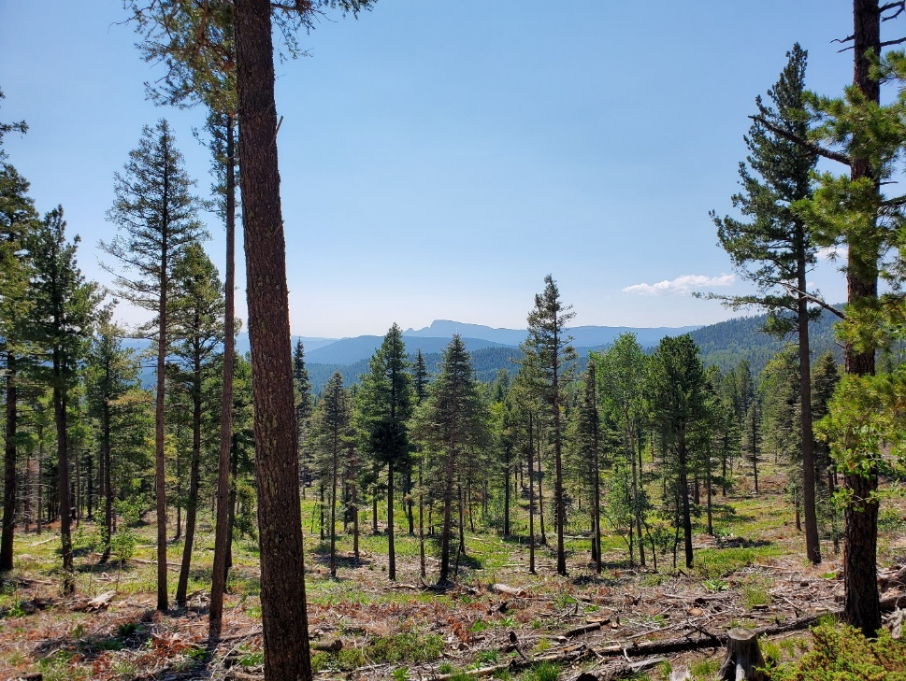
Tamera and I met in 1983, were married here in 1984. Long story short, her parents came here to our long running guest ranch as guests WITH Tamera's grandmother, who was born here in 1900 and lived here for her first 9 years. She wanted to see her childhood home, one last time. Tamera and I started writing letters back and forth after her parent’s visit and the rest is..............history!!!
Fuels reduction project on Gascon Ranch Tree Farm (2020-2021)

My father Jim, along with my brother Carl and I, decided in about 1977 that he wanted to build a sawmill from scratch, to cut lumber for use here on this 'ol ranch. We three bounced around 2 counties looking at and taking measurements of every sawmill there was, gathering ideas. We turned out the first board somewhere in 1978, and to this date I continue to saw lumber with it, at a smaller scale. At the highpoint we were turning out close to 100,000 board feet a year, exclusively custom sawing; we were also doing the logging for it.

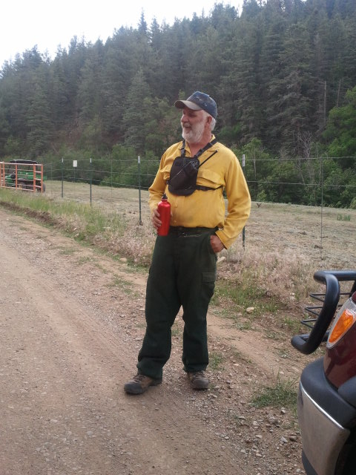
Being an actively engaged certified tree farm is very important to me. Selective harvesting, whether it be for saw logs or firewood is high on my list. I have always been afraid of a catastrophic fire; we have had two close calls, one just this summer, which was the Rincon Fire. I have always said that I would rather have fewer standing green, healthy trees, then all black ones. I was just inspected for probably the 15th or 20th time, and passed with flying colors, due to the relationship, involvement, knowledge, privilege, and HELP from many top forestry people over the years. I want to list these people because you most likely know them. I am very envious of them since I had to learn basic forestry from each and every one of them! These mentors, teachers and influential people include New Mexico State Forestry, Garry Blackwell, Mary Stuever, Doug Boykin, Todd Haines, Carol Bada, Arnie Friedt, Lawrence Crane, Shannon Atencio, Roberta Padilla, Charlie Wicklund. Consulting foresters John Harrington (like a brother to us), Harry Morrison (with Roberta helping) who wrote two beautiful, extensive management plans for this place, (plus a third that was written for us by the forestry students at New Mexico Highlands University!) I refer to these plans quite often, plus they are fun to read.
John Bartley is an active member
of the Sapello-Rociada VFD

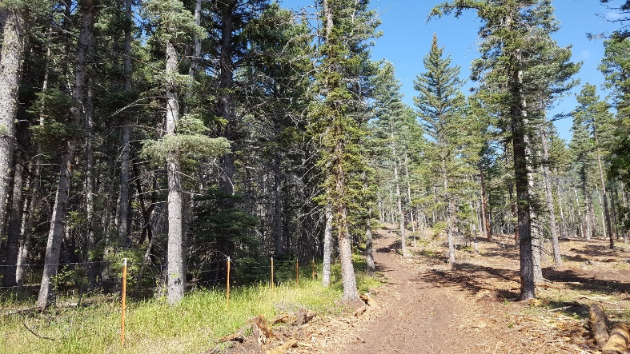
I also want to recognize Rich Edwards, forester; Eytan Krasilovski (yes, spell that name 3 times in a row on 2 cups of coffee!!), Deputy Director Forest Stewards Guild; John Formby, Ph.D., Forest Health Specialist / Entomologist; Frances Martinez with Tierra y Montes SWCD, the NRCS office in Mora with Travis Vigil and Ray Romero; plus numerous logging/thinning contractors including Jim Kellar, Roy Kuykendall, Pat Sanchez, Patrick and Robert Griego, Elias Hurtado, Chris Loewen and Tyler Ratslaff, just off the top of my head.

In addition to professional foresters, numerous fire personnel have been on the ranch over the years. Most recently the Type 2 Incident Management Team assigned to the Rincon Fire recognized the work done on this property and adjacent private properties which serves as an extensive fuelbreak bordering the overgrown Santa Fe National Forest. This team encouraged us to continue looking at ways to work with the Forest Service to expand those thinning treatments onto national forest lands.
Untreated National Forests on the left and
treated Gascon Ranch Tree Farm on the right
Over a 40+ year span I have developed my own forestry classrooms, if you will, watching and learning from these activities which are truly beneficial:
--a forest fire in 1968 (which has come back beautifully in its own way)
--mechanical logging verses conventional logging
--thinning projects
--demonstration forest
--comparing what neighbors do (thinning, chipping, masticating)
--water, ponds, wildlife
--burning

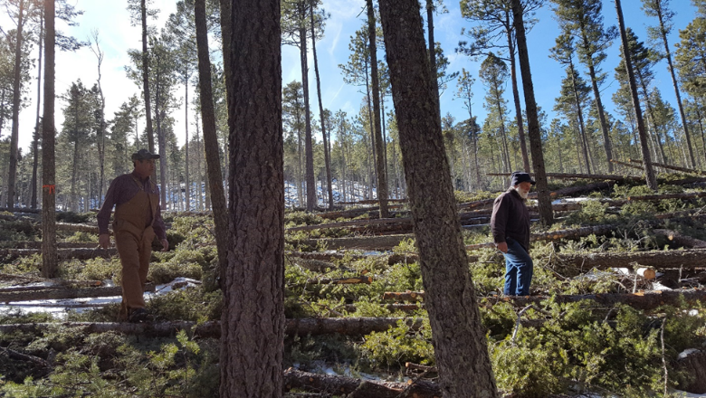
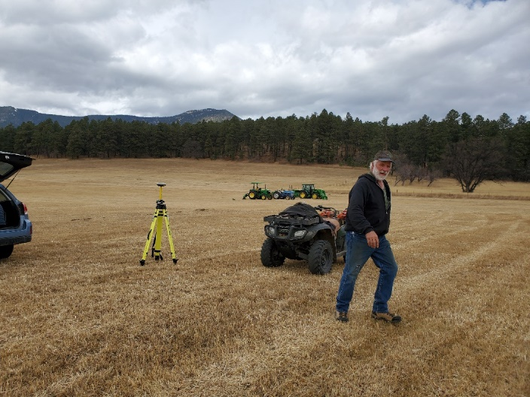
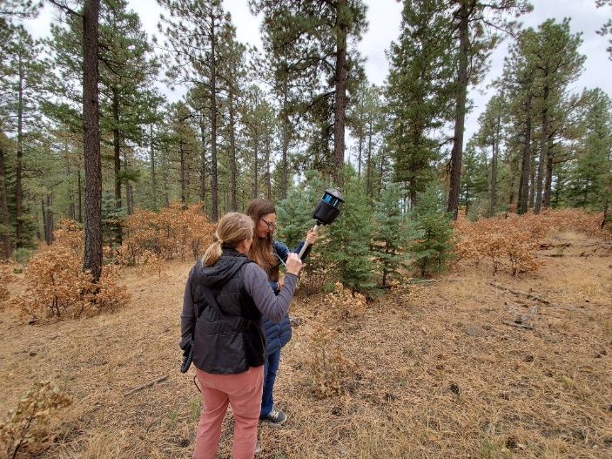
Making a living off the land is indeed rewarding and challenging. I wouldn't have it any other way. We still thin, commercial log, cut latillas and vigas, cut/split about 200 cords of wood per year, cut 600-1000 Christmas trees per year, dig live trees, boulders, etc. As mentioned earlier, being an active certified tree farm is quite an honor. Working with so many talented people over the years is an honor. I will never forget Garry Blackwell here on a tree farm tour, standing in the middle of a virgin ponderosa stand, telling me to get after it and to not be afraid to "tear it up a little"; he said don't destroy it, work it, weed it, and you'll be fine......that was in 1983 or 1984. John Harrington (God rest his soul) was the same way; he practically killed me, with covering so much ground at a marathoner’s pace (it was the same way with him on a fire!!). I wouldn't trade this life for anything........thank you to all of you guys and gals, seriously!!
John with Patrick Griego (logging contractor) survey the
treatment unit prior to skidding the logs to the log deck
John regularly gets requests to use his tree farm for various research
and educational opportunities. GIS spectialists from NM Forest and
Watershed Restoration Institute at Highlands University set up a
drone flight and also conducted LiDAR (light detection and ranging)
↓ imaging on treated units on the property in 2019 ↓

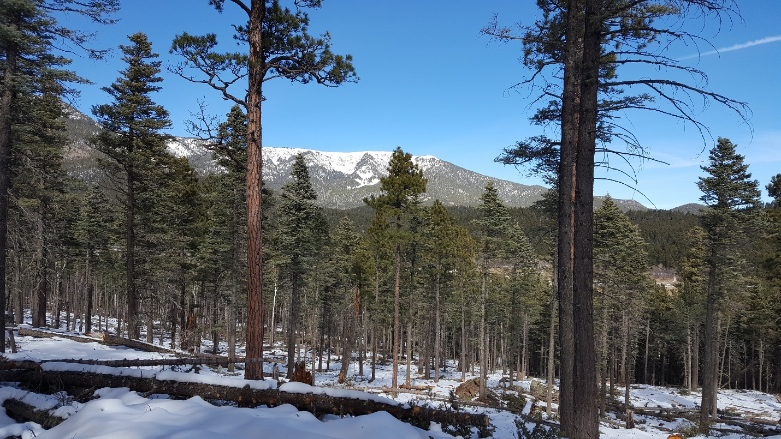

*The Gascon Ranch Tree Farm #033-81 has been involved with the New Mexico Tree Farm Program since the 1970’s and the property was officially certified in 1981. The Bartleys received recognition for New Mexico Tree Farmer of the Year in 1983 and again in 2005. The first Forest Stewardship Plan was completed for the property in 2003 through funding provided by the Stewardship Incentives Program. This plan was updated in 2016 through funding provided by the Forest Health Initiative Program. The tree farm was inspected and recertified recently on 8-30-2021 by Todd Haines, who was accompanied by Clay Benton and Shannon Atencio. Notable comments on the inspection included that management is consistent with recommendations in both forest management plans and is regularly visited by various natural resource professionals that can verify that management is going according to the plans. (*Information provided by Shannon Atencio, NM Forestry Division, Las Vegas District Forester)

1) COMMITTEE MEETING

All Tree Farmers are invited and encouraged to take part in our 3rd New Mexico Tree Farm Committee Meeting of the year (three held annually). Please join us on Wednesday, December 8th, 2021. Join us and hear what other tree farmers have been up to and share your tree farm accomplishments with the group. We look forward to visiting with you. If you have any questions, please contact Arnie Friedt at arnie.friedt@state.nm.us

