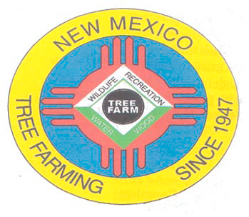
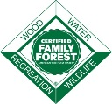
July2019

DOUG BOYKIN
Chairman,
NM Tree Farm Committee

1118 Hope Farms RoadSocorro, NM 87801
575-838-3027
Diboykin61@gmail.com
www.treefarmsystem.org/new-mexico

TREE FARM BULLETIN

Please join us in welcoming Laura McCarthy
as the New State Forester for New Mexico

The Energy, Minerals and Natural Resources Department (EMNRD) Cabinet Secretary has appointed Laura McCarthy as State Forester. EMNRD’s Forestry Division has 75 full-time employees, more than 300 seasonal firefighters, and is responsible for fire suppression on 43 million acres of on non-federal, non-municipal, non-tribal lands. Forestry also evaluates those lands and forests most at risk to wildfire, disease, and insect infestation by developing appropriate land management and restoration programs and implementing mitigation projects. McCarthy’s tenure began inMarch 2019.


“Ms. McCarthy is exceptionally well-qualified for this position,” said Secretary Sarah Cottrell Propst. “Her experience working for several New Mexico-based organizations on forest, fire, and conservation programs is exactly what we need at a time when drought and climate change are affecting our forests.”

She most recently served as the associate state director for The Nature Conservancy’s New Mexico office where she managed staff, budgets, and conservation programs to sustainably manage and protect forests, rivers, and wetlands. McCarthy created and directed the public-private partnership Rio Grande Water Fund to restore 600,000 acres of at-risk forest critical to New Mexico’s water supply.

She has over 25 years of experience in forestry-related work, including starting her career as a wildland firefighter, earning a Master of Forestry from Yale’s School of Forestry and Environmental Studies, and working for several New Mexico-based organizations on forest, fire, and conservation programs.

“My vision is to take the partnership model to accelerate forest restoration to meet the challenges we face today. I look forward to the responsibility and am excited to participate in the management and restoration of New Mexico’s forests.”

Q & A with Laura McCarthy:
What was your first position in the field of forestry?
Stand exam crew member on the Idaho Panhandle National Forest.
How long have you been in your role?
I've been a forester since 1987 and state forester since March 2019.
What do you enjoy most about being a Council of Western State Foresters member?
It's great to have a peer-group of state foresters. Each state is unique and as fire becomes the dominant driver of management in the West, and we are needing to work at ever-larger scales, we are sharing many issues.
What do you see to be the emerging issues in your state?
The scale of unplanned wildfires is dwarfing the size of our restoration treatments. Climate change scientists are predicting widespread type conversion of forests to brushfields within 50 years. Our top priority is to strategically place large treatments, and we have 10-20 years to do it. And to succeed, we will need enabling conditions to manage natural ignitions for resource benefit and for prescribed fire on all lands.
What is your favorite outdoor activity?
I love backpacking as a way to see remote forested areas and be immersed 24/7 in the outdoors.
According to the State Forestry archives, there have been a total of 10 State Foresters overseeing the Division since 1958. Ray Bell was named the first State Forester in 1958, just about a year after the first Forestry Conservation Commission was created. Smokey Bear, the living icon, was found in the Capitan Gap Fire in 1954 and was cared for by Ray Bell. Laura McCarthy is the first woman and the 11th State Forester for New Mexico.

Conservation Seedling Program Fall Sale to Begin
State Forestry Division offers new seedling species for 2019

SANTA FE, NM - The State Forestry Division Conservation Seedling Program fall sale begins
Monday, July 8, 2019. More than 57,000 tree and shrubs will be available for purchase online at nmforestry.com, including a few species not previously offered.

“We’re excited to offer a wide variety of seedlings to landowners who may be looking for something a little different,” said Conservation Seedling Program Manager Carol Bada. “This is the first year we’re offering pecan and Texas red oak”. Other seedlings include Arizona cypress, Rocky Mountain penstemon, ponderosa pine, Douglas-fir, chokecherry, New Mexico foresteria and many more.

Seedlings are available to landowners who own at least one acre of property in New Mexico. Landowners must also agree to use the seedlings for conservation purposes - this may include wildlife habitat, riparian restoration, wildlife habitat, erosion control, reforestation, Christmas tree plantations, or other conservation needs.

One-year-old seedlings are sold in 10-cubic-inch containers and available in minimum lots of 49 of the same species for $80. Multi-species bundles are offered in one-season growth containers for the same price. Two-season, large container seedlings (40 cubic inch pot) are available in lots of 20 for $57. There is a $5 handling fee per order and all sales are final.

The last day to order will be October 11, 2019. Distribution will take place between September 16 and October 18. The last day to pick up seedlings at the Santa Fe distribution center will also be October 18.

A full list of seedlings and ordering information is available at nmforestry.com. Payment with a Discover Card, Master Card, or Visa is accepted online. Checks are also accepted with mail-in application forms, which can be downloaded from the website. Landowners who wish to have an order form mailed to them should contact the New Mexico State Forestry Division at (505) 476-3325.

There is an additional $10 fee for UPS orders due to increase in shipping costs. Seedlings may also be picked up at the NM State Forestry seedling warehouse, Casa de Arboles (Tree House), 3250 Calle Princessa Juana, in Santa Fe. Hours of operation are Thursdays and Fridays, 8:30 a.m. – 12 p.m. and 1:00 p.m. – 4:30 p.m. A map to the distribution center is available online at nmforestry.com.
All proceeds are reinvested back into the NM State Forestry Conservation Seedling Program.
Bristlecone pine Arizona Cypress

Fernbush Bristlecone pine in 10-cubic-inch container
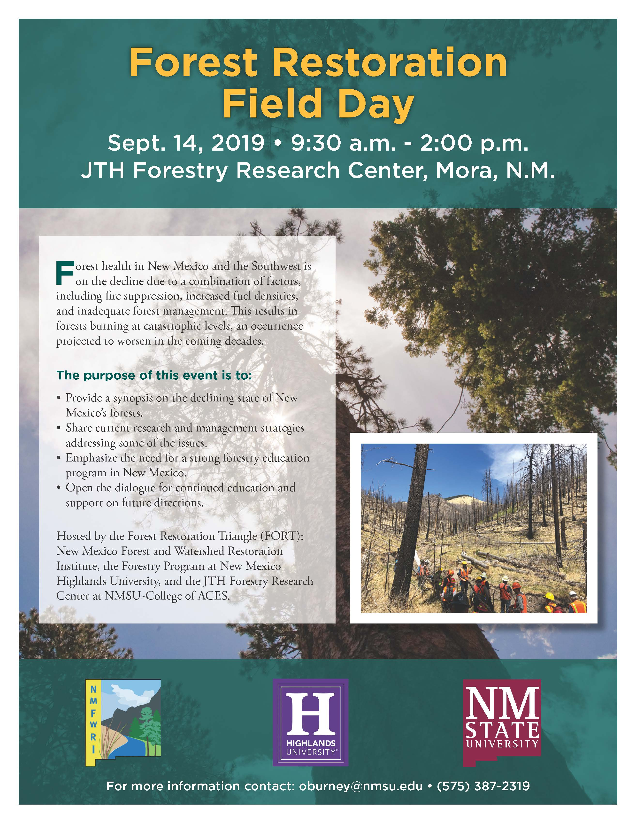
1) COMMITTEE MEETING

All Tree Farmers are invited and encouraged to attend our 2ndNew Mexico Tree Farm Committee Meeting of the year (three held annually). Please join us at 1:30 pm on Wednesday, August 14th, 2019 at the New Mexico Department of Game and Fish office located at 7816 Alamo Road. NW, Albuquerque, NM 87120. Come out and hear what other tree farmers have been up to and share your tree farm accomplishments with the group. We look forward to visiting with you. If you have any questions, please contact Arnie Friedt at arnie.friedt@state.nm.us

2) BUY, SELL OR TRADE
Are you looking for forestry related equipment to buy (i.e. chipper, splitter, chainsaw, etc.)? Or, doyou own forestry related equipment you would like to sell or trade? Forestry related equipment only, please, no homes or land. We would like to help you make the connection with other New Mexico Tree Farmers. Provide us with a description of the equipment, price, photo and contact information and we will post it in the New Mexico Tree Farm Bulletin. If you would like us to help you make the connection, please provide information to Arnie Friedt at arnie.friedt@state.nm.us

3) COMMUNITY CORNER
If your community is having a forestry related public event let us know the details and we would be delighted to promote your event in the New Mexico Tree Farm Bulletin. Give us the event details, Who, What, Where and When with contact information and we will include in our monthly bulletin.If you would like us to help you promote your event, please provide information to Arnie Friedt at arnie.friedt@state.nm.us

4) E-MAIL INSTEAD OF SNAIL MAIL
Would you prefer to receive your Tree Farm Bulletin by e-mail instead of snail mail? If so, contact Arnie Friedt at arnie.friedt@state.nm.usand provide him with your contact information. By receiving your Tree Farm Bulletin by e-mail our operating costs are reduced. Thank you for considering this option.

