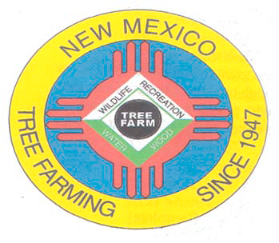
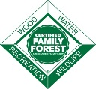
January 2022

DOUG BOYKIN
Chairman,
NM Tree Farm Committee

1118 Hope Farms Road Socorro, NM 87801
575-838-3027
Diboykin61@gmail.com
www.treefarmsystem.org/new-mexico

TREE FARM BULLETIN

POST-FIRE RECOVERY: ADAPTING TO WILDFIRE WITH TREE PLANTING AND WORKFORCE DEVELOPMENT
By Liz Bailey

Fire adapted communities must plan for before, during, and after wildfires. While developing defensible spaces, planning evacuation routes, carrying out thinning treatments, and conducting prescribed burns are all critical components of reducing risk, fire is an inevitable part of our future. In addition to the treatments that reduce the likelihood or severity of wildfire, we must also start planning for how to assist in the recovery of landscapes after fire. As wildfires and our climate become more severe, natural recovery of the landscape post-fire is becoming less likely. For landscapes that have experienced catastrophic fire that left few or no remaining trees to produce seed, planting site-adapted trees can facilitate the regeneration of forested lands. Although planting trees may seem like an intuitive way, we can help our forests recover, growing and outplanting tree seedlings remains an under-utilized practice. Further research is needed to determine what techniques, conditions, and methods produce the highest rates of survival and propagation.

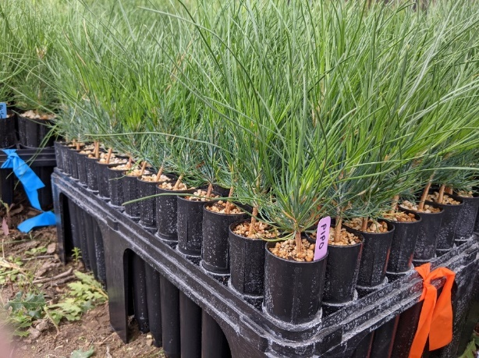
If you’ve heard of reforestation efforts in the Southwest recently, it is likely that Owen Burney and the John T. Harrington Forestry Research Center (FRC) played a role in those projects. The FRC is the largest forestry seedling producer in the Southwest and provides trees for reforestation efforts across the Southwest and Intermountain West (Photo 1). One of their many research projects, the Centers of Research Excellence in Science and Technology (CREST) project, is a large, multi-institution collaboration conducting research to examine restoration of Southwestern forests in the context of changes in forest structure and composition. The FRC’s arm of the project consists of three separate experiments each testing variables related to regeneration of post-wildfire forests. The variables tested in these three experiments include: size and density of applied nucleation (strategically planted “islands” that spread outward over time), vegetation treatments (full mechanical reduction, partial mechanical reduction, no reduction), container size, season of planting, and protection from herbivory (fencing and shelters). The results from this research will inform land managers on factors that influence regeneration of forests post-wildfire and the best methods for carrying out plantings.
Photo (1) Ponderosa pine (Pinus ponderosa) seedlings are grown in containers inside the John T. Harrington Forestry Research Center greenhouse prior to outplanting.

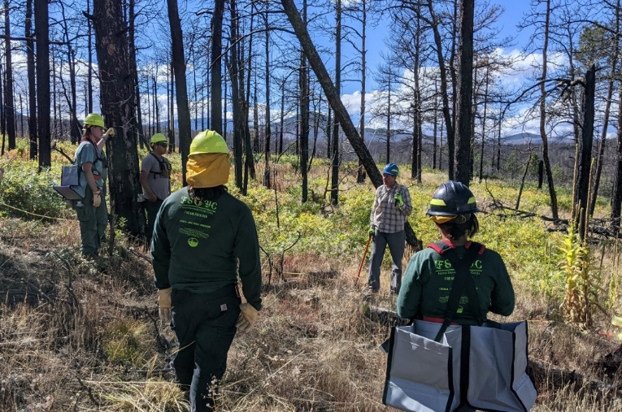
This is an ambitious project, and it required an ambitious crew to carry out the work. Fortunately, when researchers from the FRC recruited the Forest Stewards Youth Corps (FSYC) to plant over 8,000 trees for this research experiment this fall, the crews were able to overcome challenging conditions to get the job done. In the first two weeks of October, six-month old ponderosa pine (Pinus ponderosa) seedlings were planted in the burn scar of the Ute Park Fire (2018) on the Philmont Scout Ranch just outside of Cimarron, New Mexico. Trees were planted in a grid within nucleation patterns of varying sizes and densities and each plant was sheltered to prevent herbivory. These plantings were completed by The Forest Stewards Guild’s three FSYC crews which operate out of the Jemez, Mountainair, and Espanola Forest Service Ranger Districts. Individuals on these crews are 18-25 years old with an interest in careers in forestry, fire, natural resources, ecology, or related fields. The FSYC program provides job training and skill building to develop the next generation of natural resource managers (Photo 2).
Photo (2) The Ute Park Fire in 2018 burned nearly 37,000 acres near Cimarron, New Mexico, much of which was on private land including property owned by the Philmont Scout Ranch. NMSU research Owen Burney demonstrates proper planting techniques to Forest Stewards Youth Corps (FSYC) crew members.

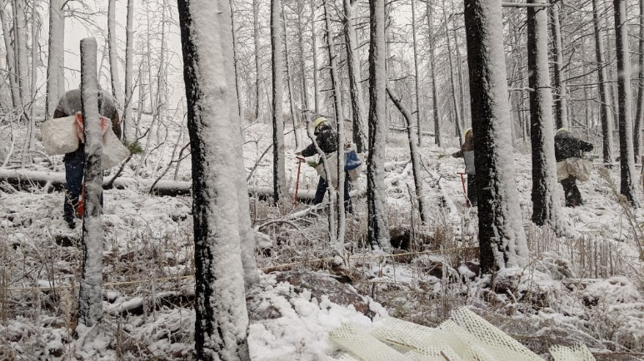
This project pushed these crew members outside of their comfort zone. There were days of intense wind which resulted in sleepless nights, broken tents, and conditions that prohibited planting. When the wind died down, crews worked through the first major snowfall of the season in cold and wet conditions. Camping for ten days straight presents a lot of challenges, particularly for our crew members who had little or no previous camping experience. There were times when morale was low and there was uncertainty as to whether we could get the work done in time, but our crews leaned on each other for support and worked hard until the very last tree was planted (Photo 3).
Photo (3) Planting continued through an early season snowstorm which, while challenging for crew members, provided ideal cool and wet conditions for the tree seedlings.

Being stewards of the land sometimes means braving harsh conditions to protect and improve our forests. This experience not only provided new learning opportunities and skills development for our crew members but fostered a new type of relationship with the land: playing an active role in restoring a landscape that would otherwise be unable to naturally recover from disturbance (Photo 4). Someday these crew members may return to this site, maybe with their own children, and find a forest that they themselves help grow.
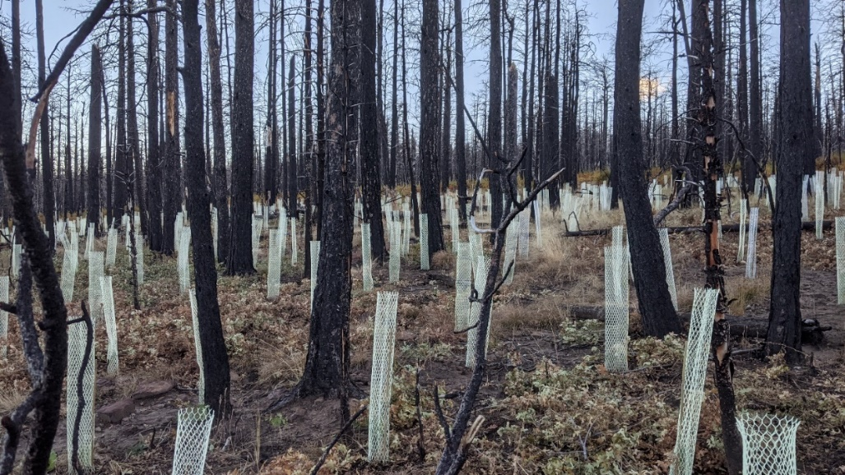
Liz Bailey is a Southwest Project Coordinator with the Forest Stewards Guild and works on a variety of projects including reforestation research in collaboration with NMSU. She has a B.A. in Public Health from Elon University in North Carolina and an M.S. in Ecology from Utah State University in Logan, UT. For any inquiries or concerns she can be reached at liz@forestguild.org
Photo (4) Once planted, tree seedlings are protected from herbivory with a photodegradable shelter to increase likelihood of survival.

BIOCHAR HELPS FOREST GROW AND STORE MORE CARBON
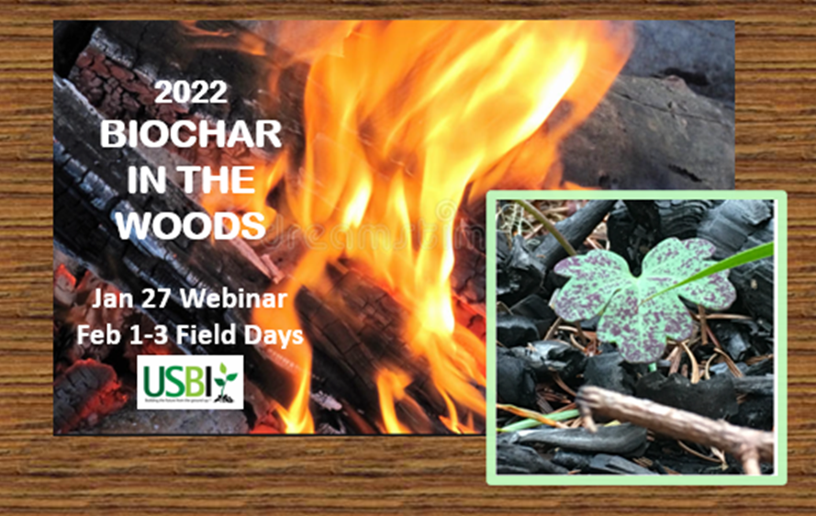
Given the ongoing drought and dangerous wildfire conditions throughout the west, US Biochar Initiative (USBI) sees an urgent need to train more people on clean techniques to convert problem forest vegetation into biochar onsite for climate and ecological benefits.

Join us at US Biochar Initiative’s Biochar in the Woods Workshop to learn how to use biochar for forest resilience and carbon sequestration. Register now for more details about the January 27, 2022 (online webinar, $50).

ONLINE WEBINAR PROGRAM Thursday, January 27 PST

Morning Session - Biochar Production and Applications 9 am - noon
- Kelpie Wilson, Wilson Biochar Associates: How to Make Biochar in Place Using Flame Cap Kilns and Conservation Burns
- Deborah Page-Dumroese, US Forest Service Research Soil Scientist: Applying Biochar to Forest Soils for Forest Health and Restoration
- Karen Youngblood: Forester, Redwood Forest Foundation, Inc
- Kai-Hoffman Krull: San Juan Islands Conservation District

Afternoon Session - Reports on Biochar Forest Projects 1- 4pm
- Laurie Schoonhoven: NRCS National Forester
- Ken Carloni: Yew Creek Land Alliance
- Mark Vander Meer, Principal Partner, Watershed Consulting, Inc.
- Dylan Maxwell, CEO, CarbonFace
- Raymond Baltar: Sonoma Biochar Initiative
- Darren McAvoy: Utah Forest Service
- Jim Archuleta: US Forest Service
- Others TBA

Who Should Attend: Forestry contractors, arborists, workforce supervisors, forest landowners, homeowners in the WUI, and staff from environmental NGOs and natural resource agencies who may be supervising forestry workers or developing biochar forestry projects and programs.

Unfortunately, the field days on February 1 – 3 will be held in California.

COMMITTEE MEETINGS/FIELD DAYS

All Tree Farmers are invited and encouraged to take part in our New Mexico Tree Farm Committee Meetings, three held annually, in March, August, and December. In addition, we host two field days annually, one in the spring and one in the fall. Dates, times, and locations to be determined. If you have any questions, please contact Arnie Friedt at arnie.friedt@state.nm.us

