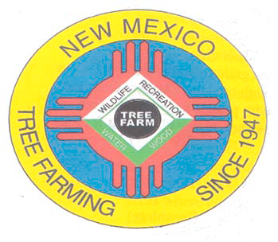
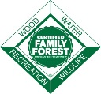
March 2022

DOUG BOYKIN
Chairman,
NM Tree Farm Committee

1118 Hope Farms Road Socorro, NM 87801
575-838-3027
Diboykin61@gmail.com
www.treefarmsystem.org/new-mexico

TREE FARM BULLETIN

This month, Parks Brigman (our Western Regional coordinator) shares a term commonly used by foresters and land managers that might help landowners gain a little better understanding of their forests and how foresters see them. Basal area is a measurement foresters use to understand the density of a stand along with volume and growth to guide their management decisions for a stand.
Basal area can be difficult to understand because it can be thought of in two slightly different ways: of an individual tree, or of all the trees in a unit of land area. The basal area of a tree is defined as the cross-sectional area (usually in square feet) of the tree at 4.5 feet from the ground. Picture a stump from above, measuring the area of the 'circle' would be basal area. When that measurement accounts for all trees in an area, its expressed per unit of area (usually per acre). Very simply put, its about how dense a stand is, or how much 'space' is taken up by the trees.
However, its not just about how many trees there are. Accounting for the size (diameter) of the trees in using this measurement gives more detailed information about how the forest might look as opposed to simply counting all of the trees in an area. Two stands can have the same basal area but look very different - a large quantity of smaller trees compared to a stand with a small quantity of larger trees. Having an idea of how diameter and basal area measurements are used together can offer a better understanding of your forest and how it can meet your objectives.
For more detailed reading, formulas, or even how you can measure basal area yourself with a string and penny, check out this article from Alabama Extension. ( www.aces.edu/blog/topics/forestry/basal-area-a-measure-made-for-management/)
Speaking from one of my own fun forestry class experiences, the same principles can apply using your thumb to measure basal area!) If you're more of an audio visual person, check out videos from South Dakota State Extension - they are really pretty good
Lastly, for all the foresters in the group, what's you go to for measuring basal area of a stand?? Prism? Angle gauge? Thumb?

Monthly Quick Stats - November 2022
Active Tree Farms - 127 Pioneer Tree Farms - 26
Prospect Tree Farms - 6 Total Acreage: 83,704
New Tree Farms: 0
Decertifications: 16 Inspections: 18

2) COMMITTEE MEETINGS

All Tree Farmers are invited and encouraged to take part in our New Mexico Tree Farm Committee Meeting of the year (three held annually). Please email my self or Todd Haines for the info for the next meeting ( time , date, location)

3) EQUIPMENT FOR SALE

4) E-MAIL INSTEAD OF SNAIL MAIL

Would you prefer to receive your Tree Farm Bulletin by e-mail instead of snail mail? Is so, contact either Todd or my self and we will get your email on the email distribution list. By receiving your Tree Farm Bulletin by e-mail our operating costs are reduced. Thank you for considering this option.

5) SAVE THE DATE

