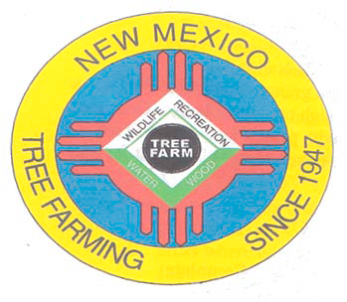
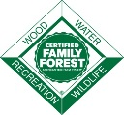
October 2021

DOUG BOYKIN
Chairman,
NM Tree Farm Committee

1118 Hope Farms Road Socorro, NM 87801
575-838-3027
Diboykin61@gmail.com
www.treefarmsystem.org/new-mexico

TREE FARM BULLETIN

TREE CONTEMPLATIONS ON THE
CONTINENTAL DIVIDE TRAIL
By Mary Stuever, Chama District Forester, NM Forestry Division

It has been four years since I hiked this section of the Continental Divide Trail with Teresa Martinez, the Executive Director of the Continental Divide Trail Coalition. I am heading south from Hopewell Lake. This time it is a day trip. This time I am alone. In my first steps from the car, I feel disoriented. There is an eerie juxtaposition of trees in the forest. In the crisp fall air, the trembling leaves of the aspens are a brilliant gold. As I look through the woods, this gold shimmer highlights a carpet of three-to-five-foot-tall aspen seedlings, so keenly contrasted with the tall, dark green conifers, Engelmann spruce and corkbark fir, that tower above them. This is what has me on edge. Typically, the pattern is reversed, the conifers are usually the seedlings growing under the tall aspen trees.

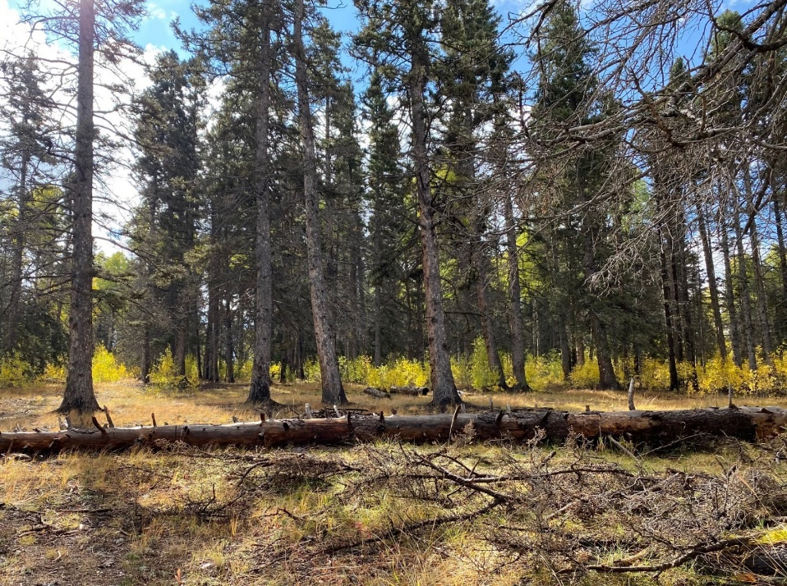
I leave the trail to explore this odd pattern. The forest is more open than the usual tightly tree-packed spruce-fir forests. Since we are in a campground, I search for stumps and signs that intense human engagement is responsible for this odd configuration. What I find is less distinct. There has been mortality in the stand in all the trees: aspen, spruce, and fir. There is more sunlight on the forest floor for these sun-loving aspen sprouts to flourish. I return to the trail humbled that the forests I have studied, worked, and played in for around a half a century continue to teach me new lessons.
I am retracing steps that Teresa and I had walked five years ago, but nearly a month later in the year. Then the aspens teased us with an occasional yellow leaf, now they are hitting their peak fall color, much of the trail is paved in gold leaves, though upon close examination, the fallen leaves include yellows, oranges, reds, browns, and greens as well. The route is much as I remember it. Climbing through forested hills, dropping down through meadows, crossing roads with various degrees of use. For nearly a mile, the trail follows an old two track road and I remember conversations when I have hiked this trail side by side with Teresa and other friends on different hikes. Further along, the trail is single track weaving through the forest when suddenly I pop out into a large clearing I don’t remember.

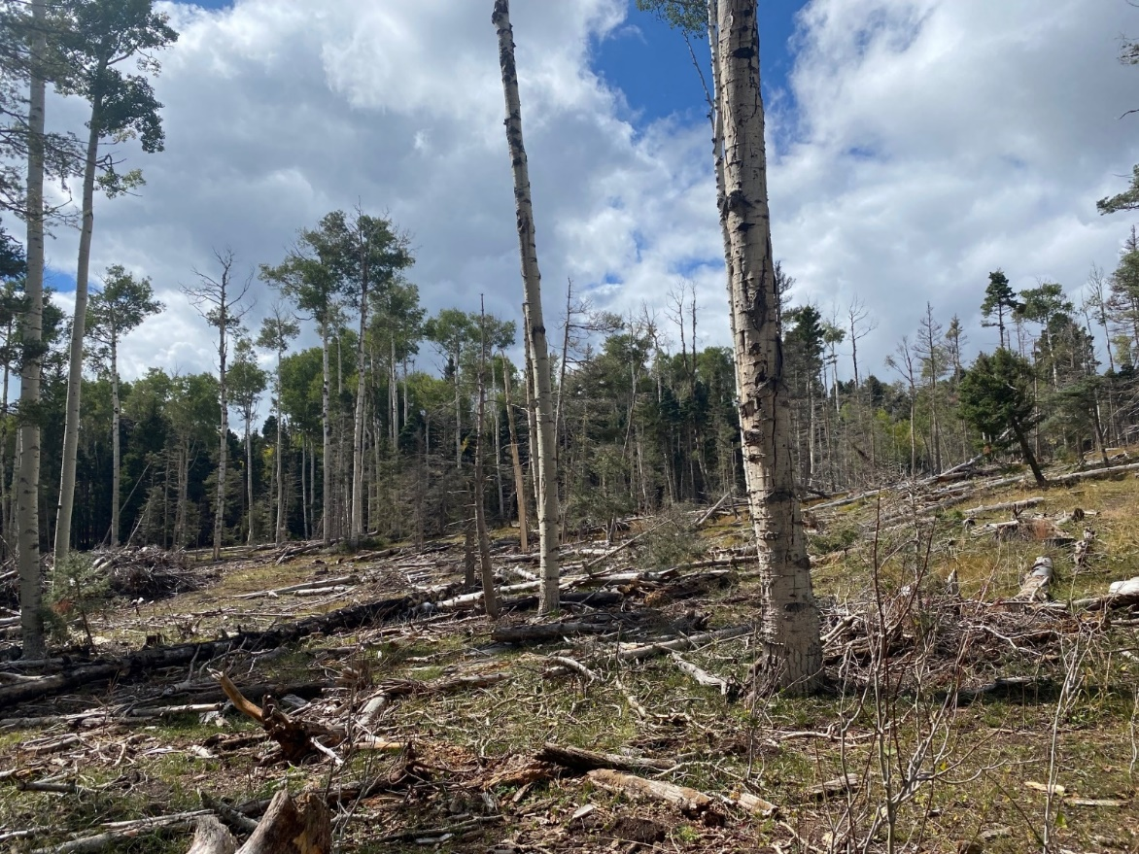
The brownish red needles on the branches of cut limbs and logs indicate the piles and scattered slash are rather recent, and almost dry enough to burn. The trail meanders into this clearing which is much larger than I first suspected. I am in a Forest Service timber sale. I remember seeing various mentions of it in my email stream at work. Still, I am surprised by the intensity of the treatment. The forest is much more open than the usual cut where the objective is to reduce stand density to decrease expected fire behavior. Instead, this cut fits the definition of a seed-tree cut, where only 10-20 trees per acre remain. I suspect the main objective is to stimulate aspen regeneration.

When Teresa and I were here, she was concerned about the paint on the trees indicating the planned treatment. Since we were not in wilderness, I didn’t share this concern. I felt it was important for the hiker to experience the forest as it is, complete with forest treatments. Teresa patiently explained that National Scenic Trail Corridors were about more than trail management…Congress expected the natural resources in the corridors to be managed in such ways that promote multiple benefits. The practice is that her office should review any planned treatments that the trail goes through. She was concerned because she had not been consulted on this particular project.

In New Mexico, except for the opinions of a few, timber sales are not terrible events, but rather tools to help transition a sickly forest to a healthy, resilient forest. Gathering this social license for tree cutting has taken decades of public outreach, written words, and, of course, devastating wildfires. Still this public approval is delicately balanced, threatening to crash down with an escaped prescribed fire, eroding skid trails in a treatment, or a prolific oak response that takes a forest from having a moderately low risk of extreme fire behavior to a forest with a moderately high risk of extreme fire behavior.

There is a mythology shared by the newly minted natural resource managers as well as the more politically oriented leadership who have spent more of their careers behind desks than in the woods. The myth is this: the impact of the legacy of fire exclusion has left our forests so dense, that doing something – anything – is better than doing nothing. Those who embrace this myth use it like a get-out-of-jail-free card. They adopt simplistic stand density goals and work their way across the landscape in a standard methodology never looking back over their shoulders at the chaos they are creating.

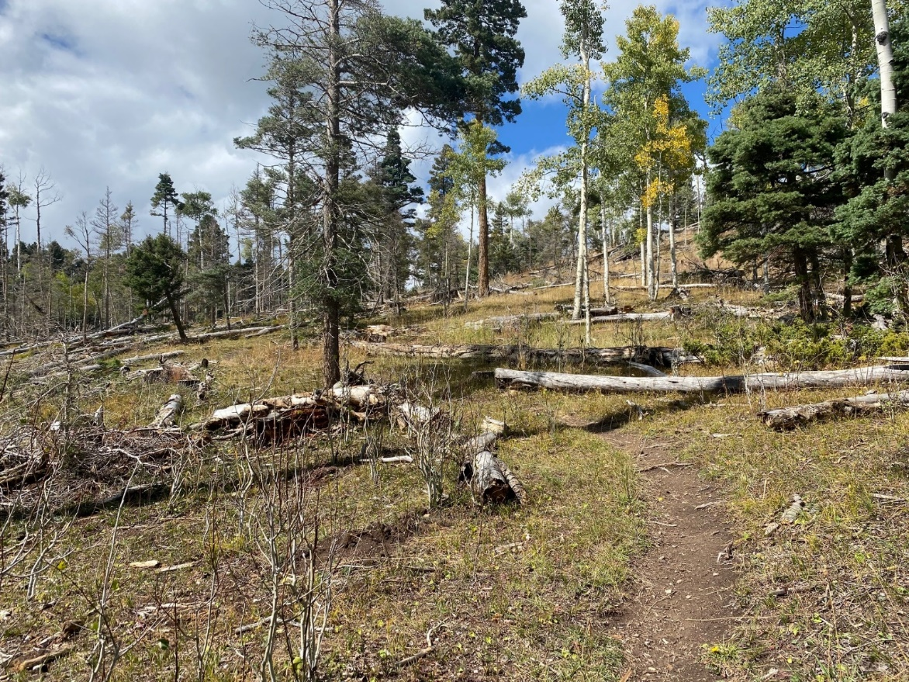
Like all myths, there is some truth that doing nothing is the worst case, but it is incredibly misleading. It is like going to a doctor with a severe headache and being offered an aspirin instead of the MRI which will either identify or rule out a brain tumor. Like doctors, foresters are educated professionals working with highly complex systems. We have access to tools and knowledge to help us create the best treatments on the landscape. No single acre is like any other, and forest treatments need to be carefully designed for each situation.

Though, I do not know exactly what the objectives for this treatment are, I am likely to know the Forest Service employees who designed it. I have faith they have good intentions with their design for this stand. As I continue hiking in the sunbaked opening, I am wishing a few more trees would have been left along the trail to offer shade, perhaps a suggestion that might have happened had there been the consultation.

It hard to double-guess another forester’s work. Like all fresh timber sales, this one is rough, and I, unlike the typical hiker on this trail, have seen enough timber sales to know that in a few years, this area will be beautiful. I think back to the humbling lesson that started off this hike. I do not know everything about forests, but I do love the opportunity to be observant, to be thinking, to be both hiker and forester who is honing her crafts.

1) COMMITTEE MEETING

All Tree Farmers are invited and encouraged to take part in our 3rd New Mexico Tree Farm Committee Meeting of the year (three held annually). Please join us on Wednesday, December 8th, 2021. Join us and hear what other tree farmers have been up to and share your tree farm accomplishments with the group. We look forward to visiting with you. If you have any questions, please contact Arnie Friedt at arnie.friedt@state.nm.us

