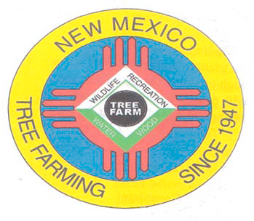
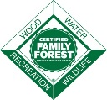
February 2022

DOUG BOYKIN
Chairman,
NM Tree Farm Committee

1118 Hope Farms Road Socorro, NM 87801
575-838-3027
Diboykin61@gmail.com
www.treefarmsystem.org/new-mexico

TREE FARM BULLETIN

NEW MEXICO TREE FARM PROGRAM
SPRING FIELD DAY
April 23rd, 2022 (10:00 AM to 2:00 PM)
By Todd Haines, Advisor, NM Tree Farm Committee

The New Mexico Tree Farm Committee is pleased to announce that Cottonwood Gulch Basecamp has been selected as the 2021 Outstanding Tree Farmer of the Year for New Mexico. An Outstanding Tree Farmer of the Year award is given to a Tree Farmer in recognition of their accomplishments on the ground and within the outreach and education realm. Cottonwood Gulch Basecamp, a 550-acre property and Outdoor Foundation in the Zuni Mountains, has been performing multiple forest health practices, including prescribed burning, and hosting prescribed burn trainings in conjunction with the Forest Stewards Guild.
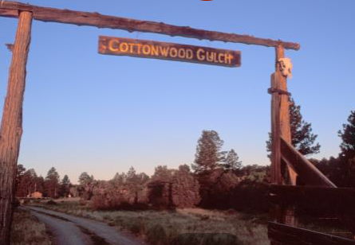
The Cottonwood Gulch Foundation Property "The Gulch," - "Base Camp” was purchased by Hillis L. Howie in 1935. The name "Cottonwood Gulch" was apparently coined by Howie to describe the cottonwood (Populus)-lined perennial stream that runs northward from the vicinity of the "Cottonwood Gulch Spring." Although apt, this name is not found on maps, except in the form "Cottonwood Gulch Camp," i.e., as the name of the cultural complex on the property. The perennial stream flows in the channel of Sawyer Creek, a name that predates 1935. The terms "Cottonwood Gulch" and "The Gulch," as used by staff, campers, alumni, and friends of the Cottonwood Gulch Foundation, typically refer to the place and the property, i.e., "Base Camp," rather than the stream.

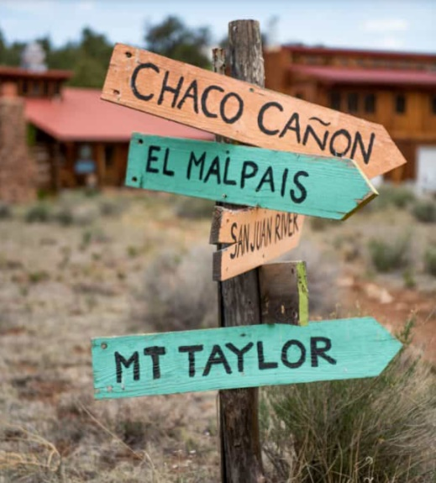
Who We Are: An early leader in outdoor education, we’ve been running unique outdoor expeditions in the Southwest since 1926. Cottonwood Gulch Expeditions is a non-profit, 501c3 organization based out of Albuquerque, NM with a 550 acre Basecamp located in Thoreau, NM. We believe that to experience true adventure, you must first have a reason to be there. To us, adventure is both feeling the thrill of your first 13,000-foot peak and the excitement of discovering how that peak came to be. We believe that knowledge provides the basis for excitement, and that to fully experience the wonder of the Southwest, we must seek to understand it. This is who we are. This is why we love what we do.

Our Mission: Cottonwood Gulch creates outdoor learning adventures for youth from all backgrounds that foster personal growth, strengthen community, and inspire stewardship of the natural world.

Our Vision: Cottonwood Gulch envisions a global community grounded in reverence for the Southwestern U.S., and respect for the lands, waters, and human cultures of the world.

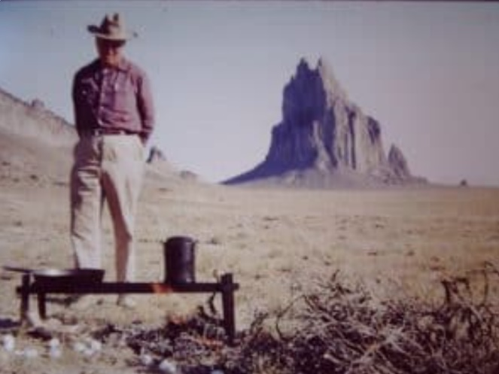
The First Prairie Trek: In the summer of 1926, a young teacher named Hillis Howie led a group of nine boys from Indianapolis to the Wild West on the first Prairie Trek Expedition. They left the Midwest in two Model T station wagons and ventured into a land that was, by all accounts, astonishingly wild. They came to see a part of America that was so rugged it remained inaccessible to all but a few. But when they dug a little deeper, they found that this land was also home to a rich legacy of human history that stretched thousands of years into the past, and they learned that with a little hard work they could begin to understand the secrets of the desert and live comfortably among its cottonwood trees and under its enormous sky.
Hillis Howie overseeing a campfire at Shiprock, 1958

In his own words, this is how Hillis Howie described those early expeditions, from the 1938 Cottonwood Gulch brochure: “The plan is to leave civilization behind and spend the months of July and August in remote and generally unknown regions of the Southwest: to establish temporary camps in sagebrush, pinon, and big timber and at ruin sites, deserted mining towns, and alpine lakes; to investigate the fauna, flora, and geology of each territory; to set a standard of camping which will be a satisfaction to ourselves and a model to others; to live a physically vigorous life with a taste of the hardships which the early explorers expected.” - Hillis Howie

1) NMTFC 2022 RAFFLE
NEW MEXICO TREE FARM COMMITTEE 2022 RAFFLE
FIRST PRIZE: Unit 45 Private Ranch Cow Elk Hunt Landowner Tag
Donated by the Gascon Ranch Tree Farm
SECOND PRIZE: Stihl Chainsaw
Donated by Forest Fitness
THIRD PRIZE: Custom Made Metal Art
Donated by Carl & Lisa Bartley
Winner of the tag will be responsible for NM Dept of Game and Fish License
Winner will need to contact the ranch to schedule hunt dates
Winners to be drawn at the August 2022 NMTFC Meeting
$10.00 Each
To purchase your 2022 Raffle ticket(s) send a letter and check (payable to NMTFC) to:
Doug Boykin
1118 Hope Farms Road
Socorro, NM 87801
Doug will in turn send you your numbered 2022 Raffle ticket stub(s)

2) COMMITTEE MEETINGS

All Tree Farmers are invited and encouraged to take part in our 1st New Mexico Tree Farm Committee Meeting of the year (three held annually). Please join us on Wednesday, March 23rd, 2022, and hear what other tree farmers have been up to and share your tree farm accomplishments with the group. We look forward to visiting with you. If you have any questions, please contact Arnie Friedt at arnie.friedt@state.nm.us

3) EQUIPMENT FOR SALE

Brand new aerator for a Multi-Flo Wastewater Treatment System. Great to have as a backup if you don’t need it now. Priced at $350.00 which is about half price. Contact Duane Trythall at DTrythall1@outlook.com or 505-821-1319.

4) E-MAIL INSTEAD OF SNAIL MAIL

Would you prefer to receive your Tree Farm Bulletin by e-mail instead of snail mail? Is so, contact Arnie Friedt at arnie.friedt@state.nm.us and provide him with your contact information. By receiving your Tree Farm Bulletin by e-mail our operating costs are reduced. Thank you for considering this option.

